Novelist

Software Development Plan (Small Project)

Version 1.1

Revision History

| **Date** | **Version** | **Description** | **Author** |
| --- | --- | --- | --- |
| 02/07/2023 | 1.0 | Project plan  Project Monitoring and Control | Nguyen Hong Hanh |
| 04/07/2023 | 1.1 | Introduction  Project overview and organization | Hoang Anh Tu |

Table of Contents

**1.** **Introduction 4**

*1.1* *Purpose 4*

*1.2* *Scope 4*

*1.3* *Overview 4*

**2.** **Project Overview 4**

*2.1* *Project Purpose, Scope, and Objectives 4*

*2.2* *Assumptions and Constraints 4*

*2.3* *Project Deliverables 5*

**3.** **Project Organization 5**

*3.1* *Organizational Structure 5*

*3.2* *Roles and Responsibilities 5*

**4.** **Management Process 5**

*4.1* *Project Estimates 5*

*4.2* *Project Plan 5*

4.2.1 Phase Plan 5

4.2.2 Iteration Objectives 6

4.2.3 Releases 6

4.2.4 Project Schedule 6

4.2.5 Project Resourcing 6

*4.3* *Project Monitoring and Control 6*

4.3.1 Requirements Management 6

4.3.2 Reporting and Measurement 7

4.3.3 Risk Management 7

4.3.4 Configuration Management 7

Software Development Plan (Small Project)

# Introduction

## Purpose

The purpose of the *Software Development Plan* is to gather all information necessary to control the project. It describes the approach to the development of the software and is the top-level plan generated and used by managers to direct the development effort.

The following people use the *Software Development Plan*:

* The **project manager** uses it to plan the project schedule and resource needs, and to track progress against the schedule.
* **Project team members** use it to understand what they need to do, when they need to do it, and what other activities they are dependent upon.

## Scope

This *Software Development Plan* describes the overall plan to be used by the Novelist project, including deployment of the product. The details of the individual iterations will be described in the Iteration Plans.  
The plans as outlined in this document are based upon the product requirements as defined in the *Vision Document*.

## Overview

This *Software Development Plan* contains the following information:

Project Overview — provides a description of the project's purpose, scope, and objectives.  It also defines the deliverables that the project is expected to deliver.

Project Organization — describes the organizational structure of the project team.

# Project Overview

## Project Purpose, Scope, and Objectives

Purpose and Objectives:

The purpose of the Novelist project is to create a comprehensive reading novel website that provides an engaging platform for readers to discover, access, and enjoy a wide range of novels. The main objectives of the project are as follows:

Novel Discovery: The website aims to provide a user-friendly interface for readers to explore and discover novels from various genres, including romance, fantasy, mystery, science fiction, and more. It will offer robust search and filtering options to help readers find novels based on their preferences.

Reading Experience: The project seeks to enhance the reading experience by providing a seamless and immersive interface.

Author Interaction: Novelist aims to foster a sense of community by allowing authors to interact with their readers. It will provide a platform for authors to showcase their works, share updates with readers through comments and forums. This will encourage a collaborative environment and enable readers to connect with their favorite authors.

Deliverables:

The Novelist project is expected to deliver the following key deliverables:

Fully Functional Website: A well-designed and intuitive website that offers a seamless and engaging reading experience for users.

Novel Database: A comprehensive database of novels covering various genres, ensuring a diverse selection for readers.

User Management System: A user registration and management system that allows readers to create accounts, manage their profiles, and track their reading progress.

Novel Discovery and Search: Robust search and filtering capabilities that enable users to easily discover novels based on their preferences.

## Assumptions and Constraints

Assumptions:

Writer's Availability: It is assumed that a capable writer is available or will be hired to complete the novel as per the project requirements.

Collaboration: It is assumed that the writer will collaborate with beta readers, literary agents, or editors to gather feedback and improve the novel's quality.

Cultural Sensitivity: It is assumed that the writer will exercise cultural sensitivity and research to accurately represent diverse characters, backgrounds, and experiences in the novel.

Reader’s Engagement: The plan assumes that the novel will incorporate elements to engage readers emotionally, intellectually, or through thought-provoking themes.

Legal Considerations: It is assumed that the writer will adhere to all legal obligations, including obtaining necessary permissions for quotes, references, or copyrighted material used in the novel.

Constraints:

Time Constraints: The project is subject to time limitations, and the novel must be completed within a specific timeframe.

Market Demand: The success of the novel may be subject to market demand and readers' preferences, which can present constraints on its reception and commercial viability.

Intellectual Property Rights: The project must adhere to copyright laws and intellectual property rights, ensuring that the content created does not infringe upon existing works.

These assumptions and constraints provide a general framework for planning and executing "The Novelist" project. However, it's essential to consider specific details, goals, and circumstances associated with your individual project to create a comprehensive list.

## Project Deliverables

* Project plan : 08/07/2023
* Software architecture: 29/07/2023
* UI design: 23/07/2023
* Program coding:
* Front-end, back-end: 30/07/2023
* Deploy website: 05/08/2023
* Product testing: 11/08/2023
* Release: 15/08/2023

# Project Organization

## Organizational Structure

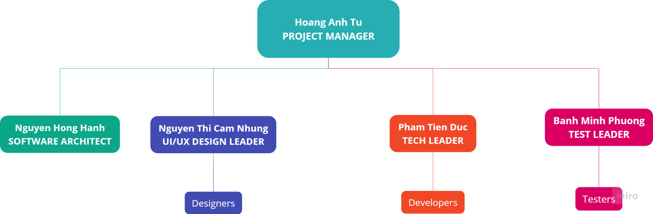

## Roles and Responsibilities

| **Person** | **Role** | **Responsibility** |
| --- | --- | --- |
| Hoang Anh Tu | Project Manager | Responsible for planning, executing, monitoring, controlling, and closing out projects, coordinating resources, managing budgets, measuring and tracking project progress |
| Nguyen Thi Cam Nhung | UI/UX Design Leader | Responsible for the user interface of the website, gathering user requirements, designing graphic elements, and developing navigation components |
| Pham Tien Duc | Tech Leader | Responsible for tech tasks, reviewing code and helping the team members with the technical aspects, such as coding and programming, working with tech risks and solve practical problems during the development stage |
| Banh Minh Phuong | Test Leader | Responsible for executing testing, including test set-up and execution, evaluation of test execution and recovery from errors |
| Nguyen Hong Hanh | Software Architect | Responsible for planning, gathering requirements, organizing and designing the software system |

# Management Process

## Project Estimates

* *Estimated cost*

| **Project Phase** | **Labor** | **Material** | **Total** |
| --- | --- | --- | --- |
| INCEPTION | 0 VND | 0 VND | 0 VND |
| ELABORATION | 0 VND | 0 VND | 0 VND |
| CONSTRUCTION | 0 VND | 0 VND | 0 VND |
| **Total** | | | 0 VND |

* *Estimated time*

**2 months**: 19/06/2023 - 19/08/2023

Estimated schedule for the project: 4.2

* *Re-estimation points and circumstances*

The re-estimation will occur:

* At the end of each phase
* When it’s behind schedule
* When there is an excess in the initial cost estimation

## Project Plan

### *Phase Plan*

* **Work breakdown structure**

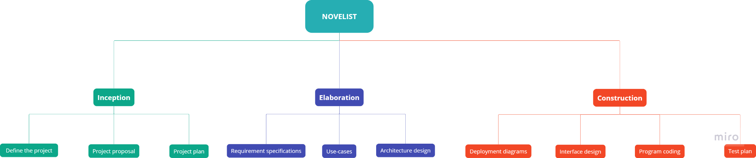

* **Phase timeline**

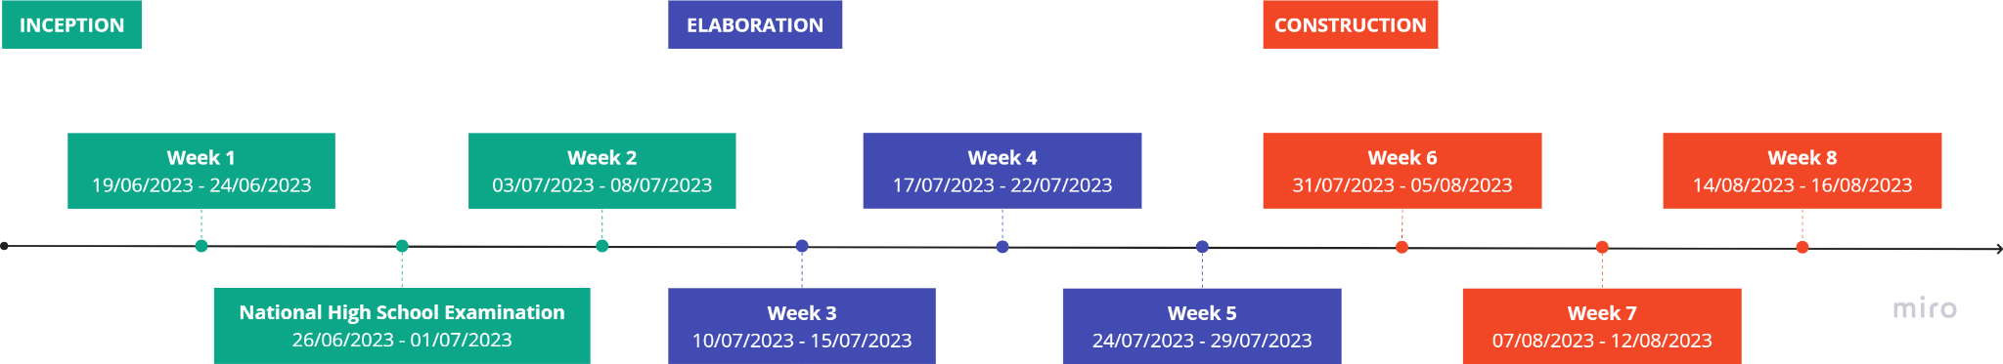

### *Iteration Objectives*

| **Phase** | **Iteration** | **Description** |
| --- | --- | --- |
| INCEPTION | Preliminary Iteration | Define the topic, requirements and project plan |
| ELABORATION | Define software architecture | Complete requirements and use-cases specifications  Architecture design for all use cases |
| CONSTRUCTION | Software development | Complete deployment diagrams and interface design  Program coding  Prepare test plan |
| Develop 1st release | Implement and test use cases |
| 2nd release - representation | Fix defects from 1st release and develop 2nd release |

### *Releases*

* **1st release**

Time: 12/08/2023

Note: All key features from a user and architectural perspective are implemented

* **2nd release (Representation)**

Time: 16/08/2023

Note: Defects minimized and all key functionalities are implemented

### *Project Schedule*

| **ID** | **Task** | **Start date** | **End date** | **Dependencies** |
| --- | --- | --- | --- | --- |
| **PP** | **Project plan** | | | |
| PP1 | Project overview & organization | 19/06/2023 | 08/07/2023 |  |
| PP2 | Project plan & risk management |  |
| PP3 | Project features & product requirements |  |
| PP4 | Product position |  |
| PP5 | Stakeholder and User Descriptions |  |
| **SA** | **Software architecture** | | | |
| SA1 | Design use-case diagram | 10/07/2023 | 19/07/2023 | PP3 |
| SA2 | Use-case specification | PP3 |
| SA3 | Model class diagrams | 20/07/2023 | 24/07/2023 | SA2 |
| SA4 | Deployment diagrams | 24/07/2023 | 29/07/2023 | AD3 |
| **UD** | **UI design** | | | |
| UD | Sketch the user interface | 20/07/2023 | 23/07/2023 | SA2 |
| **PC** | **Program coding** | | | |
| PC1 | Front-end | 24/07/2023 | 30/07/2023 | SA, UD |
| PC2 | Back-end | SA, UD |
| PC3 | Deploy website | 31/07/2023 | 05/08/2023 | PC1, PC2 |
| **PT** | **Product Testing - 1st release** | | | |
| PT1 | Prepare test plan | 31/07/2023 | 05/08/2023 | AD |
| PT2 | Execute test | 07/08/2023 | 09/08/2023 | PT1, PC |
| PT3 | Test summary report | 09/08/2023 | 11/08/2023 | PT2 |
|  | **2nd release** | | | |
| T0 | Fix detects | 12/08/2023 | 15/08/2023 | PT |
| T1 | Product release & representation prepare | PT |

### *Project Resourcing*

| **Assigned to** | **ID** | **Task** | **Knowledge Requirements** |
| --- | --- | --- | --- |
| **Lead: Hoang Anh Tu** | **PP** | **Project plan** |  |
| Hoang Anh Tu | PP1 | Project overview & organization |  |
| Nguyen Hong Hanh | PP2 | Project plan & risk management |  |
| Nguyen Thi Cam Nhung | PP3 | Project features & product requirements |  |
| Banh Minh Phuong | PP4 | Product position |  |
| Pham Tien Duc | PP5 | Stakeholder and User Descriptions |  |
| **Lead: Nguyen Hong Hanh** | **SA** | **Software architecture** | UML |
| Nguyen Hong Hanh | SA1 | Design use-case diagram |
| Banh Minh Phuong  Nguyen Thi Cam Nhung | SA2 | Use-case specification |
| Pham Tien Duc | SA3 | Model class diagrams |
| Hoang Anh Tu | SA4 | Deployment diagrams |
| **Lead: Nguyen Thi Cam Nhung** | **UD** | **UI design** |  |
| Nguyen Thi Cam Nhung | UD | Sketch the user interface | Figma |
| **Lead: Pham Tien Duc** | **PC** | **Program coding** | HTML  CSS  JavaScript  Python |
| Nguyen Hong Hanh  Banh Minh Phuong | PC1 | Front-end |
| Pham Tien Duc  Hoang Anh Tu | PC2 | Back-end |
| PC3 | Deploy website |
| **Lead: Banh Minh Phuong** | **PT** | **Product Testing - 1st release** |  |
| Banh Minh Phuong | PT1 | Prepare test plan |  |
| Banh Minh Phuong  Nguyen Thi Cam Nhung | PT2 | Execute test |  |
| Banh Minh Phuong | PT3 | Test summary report |  |
| **Lead: Hoang Anh Tu** | **2nd release** | |  |
|  | T0 | Fix detects |  |
|  | T1 | Product release & representation prepare |  |

## Project Monitoring and Control

### *Requirements Management*

The requirements for this system are captured in the Vision document. Requested changes to requirements are captured in Change Requests, and are approved as part of the Configuration Management process.

### *Reporting and Measurement*

### *Risk Management*

Risks will be identified in Inception Phase using the steps identified in the RUP for Small Projects activity “Identify and Assess Risks”. Project risk is evaluated at least once per iteration and documented in this table. The risks of the greatest magnitude are listed first in the table.

| **Risk Ranking (High, Medium, Low)** | **Risk Description and Impact** | **Mitigation Strategy and/or Contingency Plan** |
| --- | --- | --- |
| High | Member is not capable of completing a task due to their skills  → Overdue task | Members help each other to learn the skills needed to complete the given task  The leader needs to be sure about members’ ability when allocating tasks |
| High | Can not complete tasks in time due to mistakes in previous processes  → Behind schedule and late delivery | Double check before moving on  Ask for TA’s feedback and advice |
| High | A change in requirements results in redesigning from scratch  → Major rework | Make sure of requirements list before implementing  Cut down unnecessary features  Ask for TA’s feedback and advice |
| High | Facing issues with safety and security  → Loss of data | Make sure to backup all the project in all period  Ask for TA’s feedback and advice |
| Medium | Some members have to quit the project because of personal problems  → Task cancellation and lack of human resource | Make sure that all members have to clearly understand the work of each teammate  A member is required to hand over all his/ her work to another teammate before quitting the project |
| Low | Members are in argument with each other | All members are responsible for resolving arguments between teammates  All members must commit to completing oneself’s task without being affected by arguments |

### *Configuration Management*